St. Andrew’s Academy

CFE Higher Chemistry

Numeracy and Problem Solving Questions

- The nutritional information states that 100 g of margarine contains 0.70 g of sodium. The sodium is present as sodium chloride. Calculate the mass of sodium chloride, in g, present in every 100 g of margarine. The mass of one mole of sodium chloride, NaCl, is 58·5 g.

- The emulsion contains 2 g of ibuprofen in every 100 cm3 of emulsion.
The recommended dose for treating a 6 month old baby is 0·050 g.
Calculate the volume, in cm3, of “infant formula” needed to treat a
6 month old baby.

- The chemist managed to make 5·75 g of butan-2-ol using 5·01 g of propanal
and 20·0 g of methyl magnesium bromide.
The costs of the chemicals used are shown below:

Propanal | £22·10 for 1 kg
Methyl magnesium bromide | £75·00 for 25 kg
Calculate the cost of the chemicals needed to produce 100 g of butan-2-ol
using this method.

- Zinc is an essential element for the body and is found in a variety of foods.
(a) The mass of zinc in four 100 g samples taken from a cheese spread was
measured.
Sample | Mass of Zn/mg
1 | 4.0
2 | 21.7
3 | 3.9
4 | 4.1

Calculate the average mass of Zn, in mg, in 100 g of this cheese spread.

(b) The recommended daily allowance of zinc is 9·5 mg for an adult male.
100 g of peanuts contains 3·3 mg of zinc.

Calculate the mass of peanuts which would provide the recommended daily
allowance of zinc.

- Petrol is a fuel used in cars.
Energy released when 1·00 g of petrol burned/kJ | 48
Volume of 1·00 g of petrol/cm³ | 1.45
A car has a 50·0 litre petrol tank.

Calculate the energy, in kJ, released by the complete combustion of one tank of petrol.

- A mixture of magnesium bromide and magnesium sulfate is known to contain 3 mol of magnesium and 4 mol of bromide ions.
How many moles of sulfate ions are present?
A 1
B 2
C 3
D 4

- Theobromine, a compound present in chocolate, can cause illness in dogs and cats. To decide if treatment is necessary, vets must calculate the mass of theobromine consumed.

1·0 g of chocolate contains 1·4 mg of theobromine.

Calculate the mass, in mg, of theobromine in a 17 g biscuit of which 28% is
chocolate. Show your working clearly.

- The maximum safe dose of lidocaine for an adult is 4·5 mg of lidocaine per kg of body mass. 1·0 cm³ of lidocaine solution contains 10 mg of lidocaine.

Calculate the maximum volume of lidocaine solution that could be given to a 70 kg adult. Show your working clearly.

- Whisky contains a higher concentration of ethanol.
(i) Before 1980, the concentration of alcohol in drinks was measured in
terms of degrees proof. The concentration of alcohol in two drinks is shown in the table below,both as % abv and degrees proof.
Sample | Alcohol  concentration  / % abv | Alcohol  concentration  / degrees proof
Wine | 14 | 24.5
Sherry | 20 | 35

A cask strength whisky has an alcohol concentration of 65% abv.
Calculate the alcohol concentration of this whisky in degrees proof.

(ii)A barrel containing 195 litres of cask strength whisky costs £1300.
The cask strength whisky is diluted with water to reduce the concentration of alcohol from 65% abv to 46% abv before it is bottled.

Calculate the cost of the cask strength whisky needed to produce a 0·70 litre bottle. Show your working clearly.

- Argon is also in the third period. Argon is a very useful gas and each year 750 000 tonnes of argon are extracted from liquid air.
Air contains 1·3% argon by mass.
Calculate the mass of liquid air needed to obtain 750 000 tonnes of argon.

- The energy density value of a fuel is the energy released when one kilogram of the fuel is burned.
The enthalpy of combustion of ethanol is −1367 kJ mol−1.
Calculate the energy density value, in kJ kg−1, of ethanol

- The recommended daily allowance (RDA) for vitamin C is 60 mg.
A one litre carton of an orange fruit drink contains 240 mg of vitamin C.
What percentage of the RDA is provided by 200 cm3 of this drink?

- 5·0 g of behenic acid can be obtained from 50·0 cm³ of ben oil.
1 litre of ben oil costs £90.
How much would it cost to buy sufficient ben oil to produce 20·0 g of behenic acid?

- A student prepared a sample of methyl cinnamate from cinnamic acid and Methanol.
Cinnamic acid + Methanol methyl cinnamate +water
Mass of 1mole Mass of 1mole Mass of 1mole
=148g =32g =162g

The student wanted to scale up the experiment to make 100 g of methyl cinnamate. The actual yield is 52%.

Cinnamic acid costs £35·00 per 250 g.

Calculate the cost of cinnamic acid needed to produce 100 g of methyl cinnamate.

- Coumarin is another compound found in the brand name perfume. It is
present in the spice cinnamon and can be harmful if eaten in large quantities.

The European Food Safety Authority gives a tolerable daily intake of
coumarin at 0·10 mg per kilogram of body weight. 1·0 kg of cinnamon powder from a particular source contains 4·4 g of coumarin.

Calculate the mass of cinnamon powder, in g, which would need to be consumed by an adult weighing 75 kg to reach the tolerable daily intake.
- The products formed when an explosive substance decomposes can be predicted by applying the Kistiakowsky-Wilson rules. These rules use the number of oxygen atoms in the molecular formula to predict the products.
In the example below these rules are applied to the decomposition of the explosive RDX, C₃H₆N₆O₆
Rule Number | Rule | Atoms available in C₃H₆N₆O₆ | Apply Rule to show products
1 | Using oxygen atoms from the formula convert any carbon atoms in the formula to carbon monoxide. | 3 × C | 3CO formed
2 | If any oxygen atoms remain convert H atoms in the formula to water. | 3 × O remain | 3H2O formed
3 | If any oxygen atoms still remain then convert CO formed to CO2. | No more oxygen left | No CO2 formed
4 | Convert any nitrogen atoms in the formula to N2. | 6 × N | 3N2 formed
Decomposition equation:
C₃H₆N₆O₆(s) → 3CO(g) + 3H₂O(g) + 3N₂(g)
By applying the same set of rules, complete the equation for the decomposition of the explosive PETN, C₅H₈N₄O₁₂.

C₅H₈N₄O₁₂(s) →

- Sodium chloride is added during manufacture to increase the viscosity of
handwashes.
In an investigation to measure the effect of sodium chloride on the viscosity of handwash, the following results were obtained.

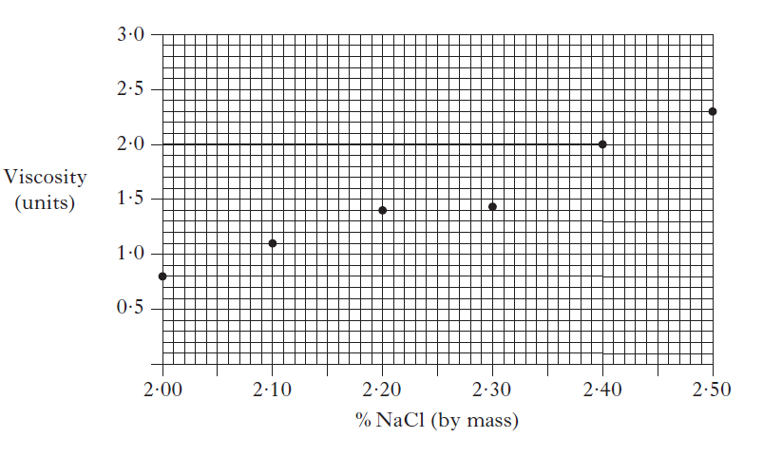
Use the graph to calculate the mass of sodium chloride, in grams, that should be added to 1 litre of handwash to give a viscosity of 1·5 viscosity units.
(Take the mass of 1 cm³ of handwash to be 1·1 g)

- The colour of a handwash is due to the wavelengths of light that pass through the handwash, ie, are not absorbed. A handwash contains two dyes, E133 and E102, which absorb light of particular wavelengths. The typical wavelengths associated with some colours are shown in the table.
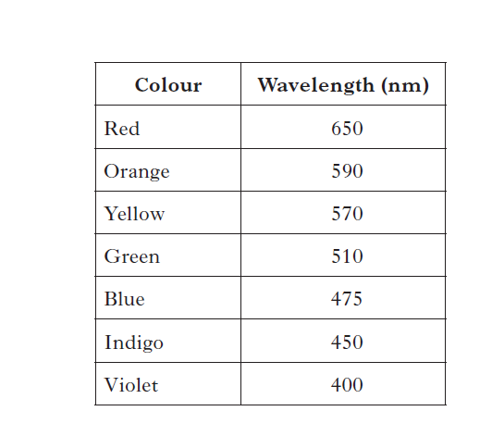
The peaks in the following spectra show the wavelengths of light absorbed by each of the two dyes.

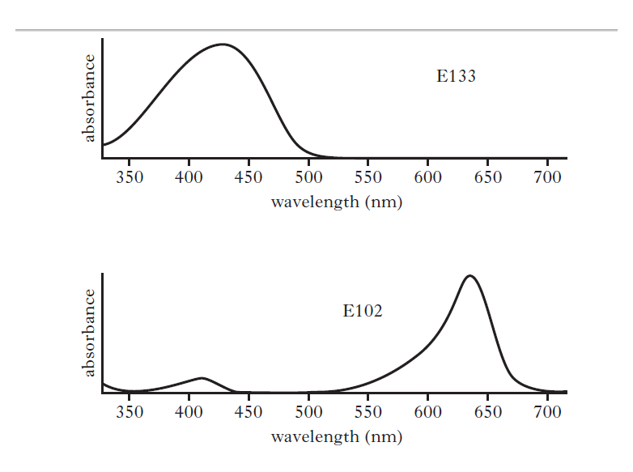
State the colour of the handwash.

- The level of hypochlorite in swimming pools needs to be maintained between 1 and 3 parts per million (1–3 ppm).

400 cm³ of a commercial hypochlorite solution will raise the hypochlorite level of 45 000 litres of water by 1 ppm.

Calculate the volume of hypochlorite solution that will need to be added
to an Olympic sized swimming pool, capacity 2 500 000 litres, to raise the
hypochlorite level from 1 ppm to 3 ppm.

- The recommended daily allowance (RDA) for vitamin E is 20 mg per day. Almonds are a good source of vitamin E and provide 26·2 mg per 100 g. Almonds are sold as 1 kg bags costing £13·99.
Calculate the cost of almonds that will provide the RDA of vitamin E.

- The concentration of paracetamol in a solution can be determined by measuring how much UV radiation it absorbs.
The quantity of UV radiation absorbed is directly proportional to the concentration of paracetamol.
The graph shows how the absorbance of a sample containing 0·040 g l-1 paracetamol varies with wavelength.
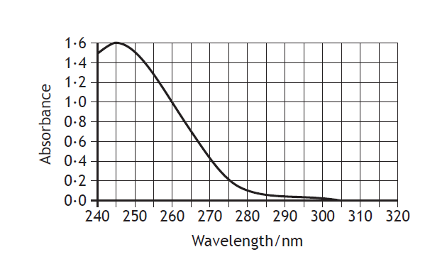
The absorbance of a second sample of paracetamol solution measured at 245 nm was 0·90. Determine the concentration, in g l-1, of this second paracetamol solution.

- Eggs and fish are good dietary sources of the essential amino acid, methionine. The recommended daily allowance of methionine for an adult is 15 mg per kg of body mass.

Tuna contains 755 mg of methionine per 100 g portion.

Calculate the mass, in grams, of tuna that would provide the recommended daily allowance of methionine for a 60 kg adult.

- The student determined the density of the alcohols by measuring
the mass of a volume of each alcohol.

The student’s results are shown below:
 | Methanol | Ethanol
Volume of alcohol (cm³) | 25 | 25
Mass of alcohol (g) | 19.98 | 20.05
Density of alcohol (g cm⁻³) |  | 0·802

Calculate the density, in g cm−3, of methanol.

- Parabens can be used as preservatives in cosmetics and toiletries.
Parabens are absorbed into the body through the skin. The following
table indicates the absorption of some parabens:
Paraben | Absorption (μg cm⁻²)
Methyl | 32.50
Ethyl | 20.74
Propyl | 11.40
Butyl | 7.74
Hexyl | 1.60
State a conclusion that can be drawn from the information in the table.

- During the First World War, some people died following Government
advice to eat rhubarb leaves. This was partly due to the oxalic acid
present.

The lethal dose of oxalic acid for humans is estimated to be 375 mg per kg of body mass.

The concentration of oxalic acid in rhubarb leaves is 0·72 g per 100 g of leaves .

Calculate the mass of rhubarb leaves that a person with a mass of 65 kg would need to consume to reach the lethal dose.

- During colorimetric analysis, 0·35 g of an aluminium alloy was dissolved in nitric acid. The manganese in the resulting solution was oxidised and the solution was made up to 250 cm³.
The concentration of this solution was found to be 4·25 × 10−4 mol l−1.
Calculate the percentage, by mass, of manganese in the alloy.

